Agile Scrum Master Project
SMART WEATHER (WITH JIRA)
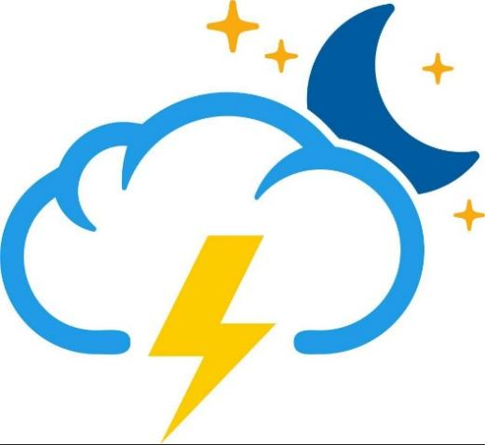

Submitted by- Kaveri
Table Of Content
Task1 | Identify at least five epics and 15 user stories from the case. Link the stories to the epics
Task2 | Get a free JIRA account and create a Scrum project.
Task3 | Enter the backlogs (epics, stories and subtasks) in JIRA.
Task4 | Make a tentative release plan, by assigning the stories to three sprints.
Task5 | Start and complete one sprint

Introduction
The case focuses on GTM Systems, a leading global IT organization that provides software solutions and services to enterprise clients across various industries. In this project, I assumed the role of a Business Analyst and utilized Agile Scrum methodologies to plan and manage the development of a hypothetical product. The project activities were executed on JIRA, a widely-used Agile project management tool. The project focused on Smart Weather, a hypothetical initiative by GTM Systems, aimed at delivering predictive weather-based insights to support industries such as agriculture, tourism, and healthcare.

Objective
The objective is to gain hands-on experience in Agile planning, facilitate team collaboration, and ensure continuous delivery of value. The iterative approach helped in refining requirements, responding to change, and practicing real-world Agile delivery frameworks. This assignment enhanced my understanding of agile roles, ceremonies, and artifacts while applying them in a professional tool used across the industry.

Tasks 1
Identify at least five epics and 15 user stories from the case. Link the stories to the epics.
Epic | User Story
User management and access control. | - As a user, I want to register as a free user so that I can access basic weather information.  - As a user, I want to upgrade to a paid account so that I can access premium features without Ads.  - As a user, I want to manage my subscription so that I can access my plan as needed.
Weather data collection and Integration. | 4.As a system, I want to integrate with multiple public weather services so that I can aggregate data.  5. As a system, I need to locate the user location via GPS or IP so that I can provide local weather updates.  6. As a system, I need to store weather data in database by location so that I serve accurate and up to date forecast.
Weather overview and Analysis. | 7 .As a user, I want to see current weather at my location so that I can plan my day.  - As a user, I want to see 5,10,15 days forecast so that I can make informed travel plans.  - As a user, I want to see the seasonal forecast so that I can prepare for season changes.
Business Features, Service integration and revenue generation. | - As a business, I want to display advertisements on portals and app so that I can generate revenue from free users.  - As a business, I want to provide severe weather advisories to paid users so that I can keep them engaged.  - As a business, I want to offer APIs for client app so that I can get third party integration and expand my user base.
User experience and multi platform support. | - A a user , I want a responsive web portal that works on all devices so that I can access weather information anywhere.  - As a user, I want to use the smart weather app on my ios and android device so that I can check weather on the go.  - As a user, I want to see satellite images and time-lapse videos so that I can better understand weather pattern.

Task 2

Get a free JIRA account and create a Scrum project.
I created a JIRA account and built a scrum project titled “Smart Weather Solution (SWS)”.
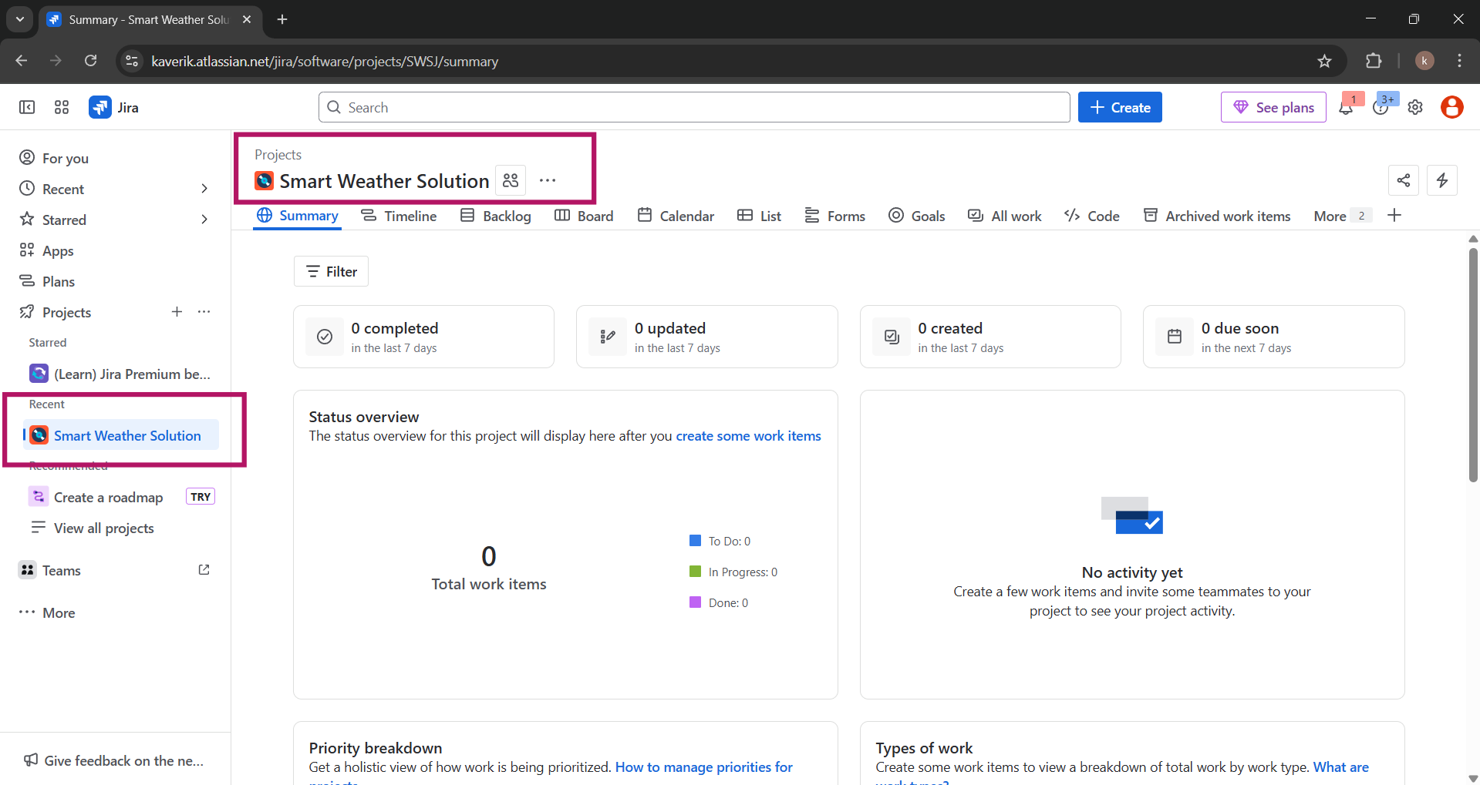

Task 3
Enter the backlogs (epics, stories and subtasks) in JIRA.

Epics
The below screenshot highlights the creation of 5 key epics in JIRA. Each epic represents a major functional module of the Smart Weather system, enabling structured backlog management and clear project segmentation.
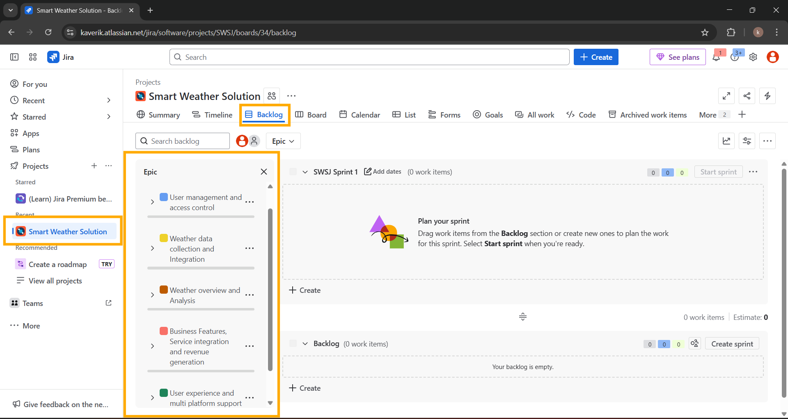
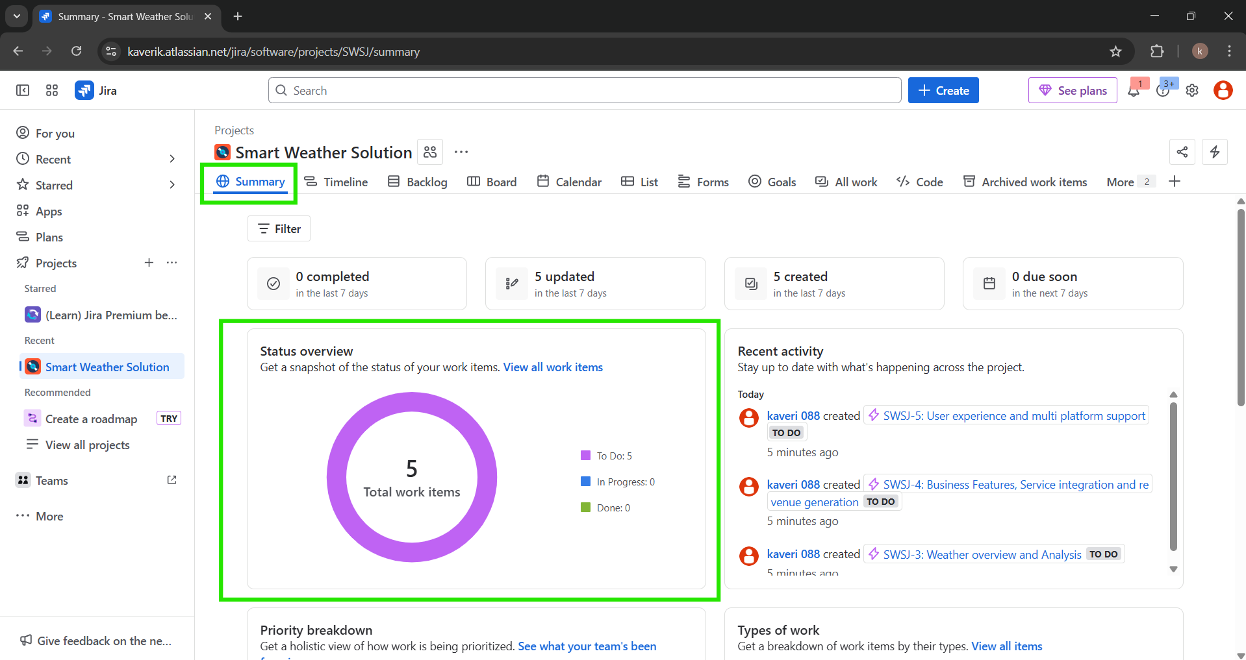

The backlog board is organized to visualize work status during the sprint cycle. This helps the team track progress, encourages daily stand-ups, and supports agile delivery.

User Stories

User stories are written in the format “As a user/system… so that…”, clearly showing stakeholder needs. They are mapped to respective EPICS to ensure traceability.
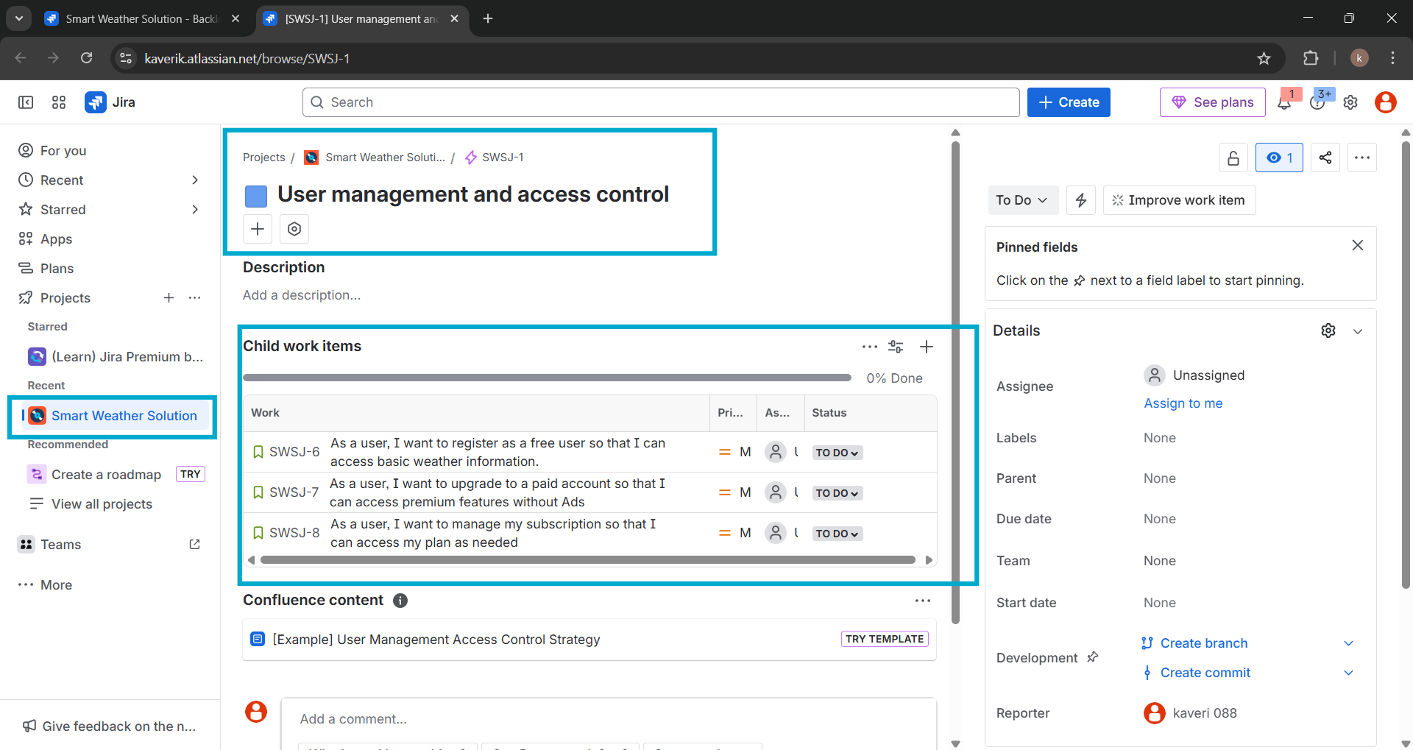
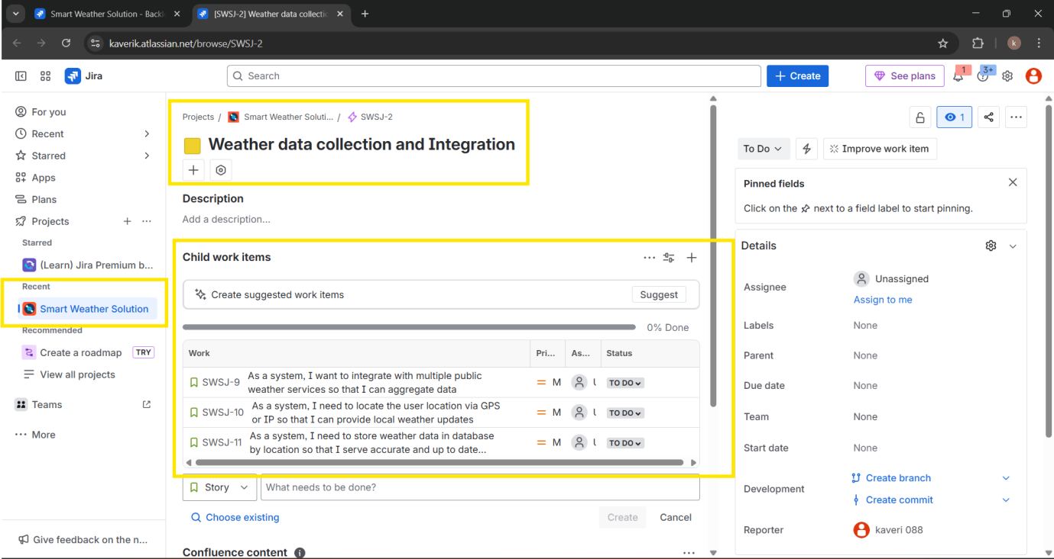

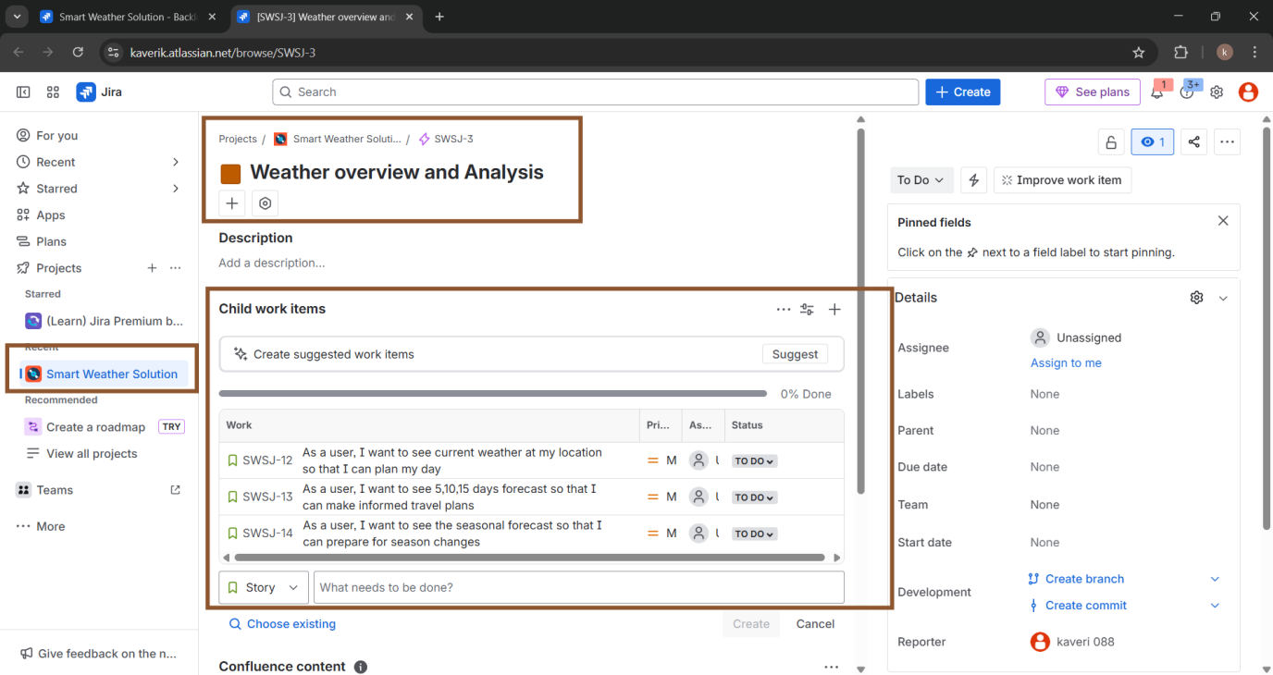

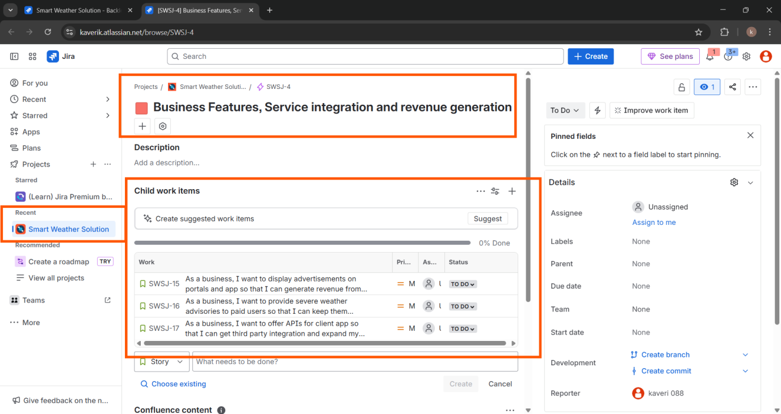

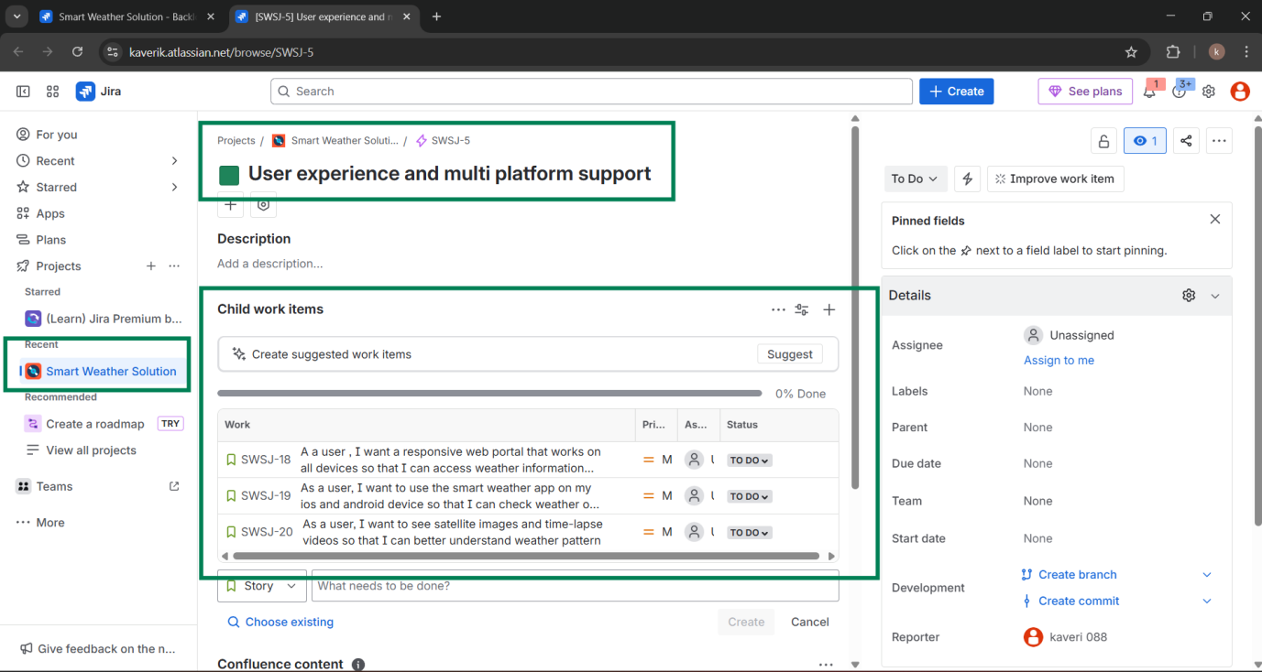
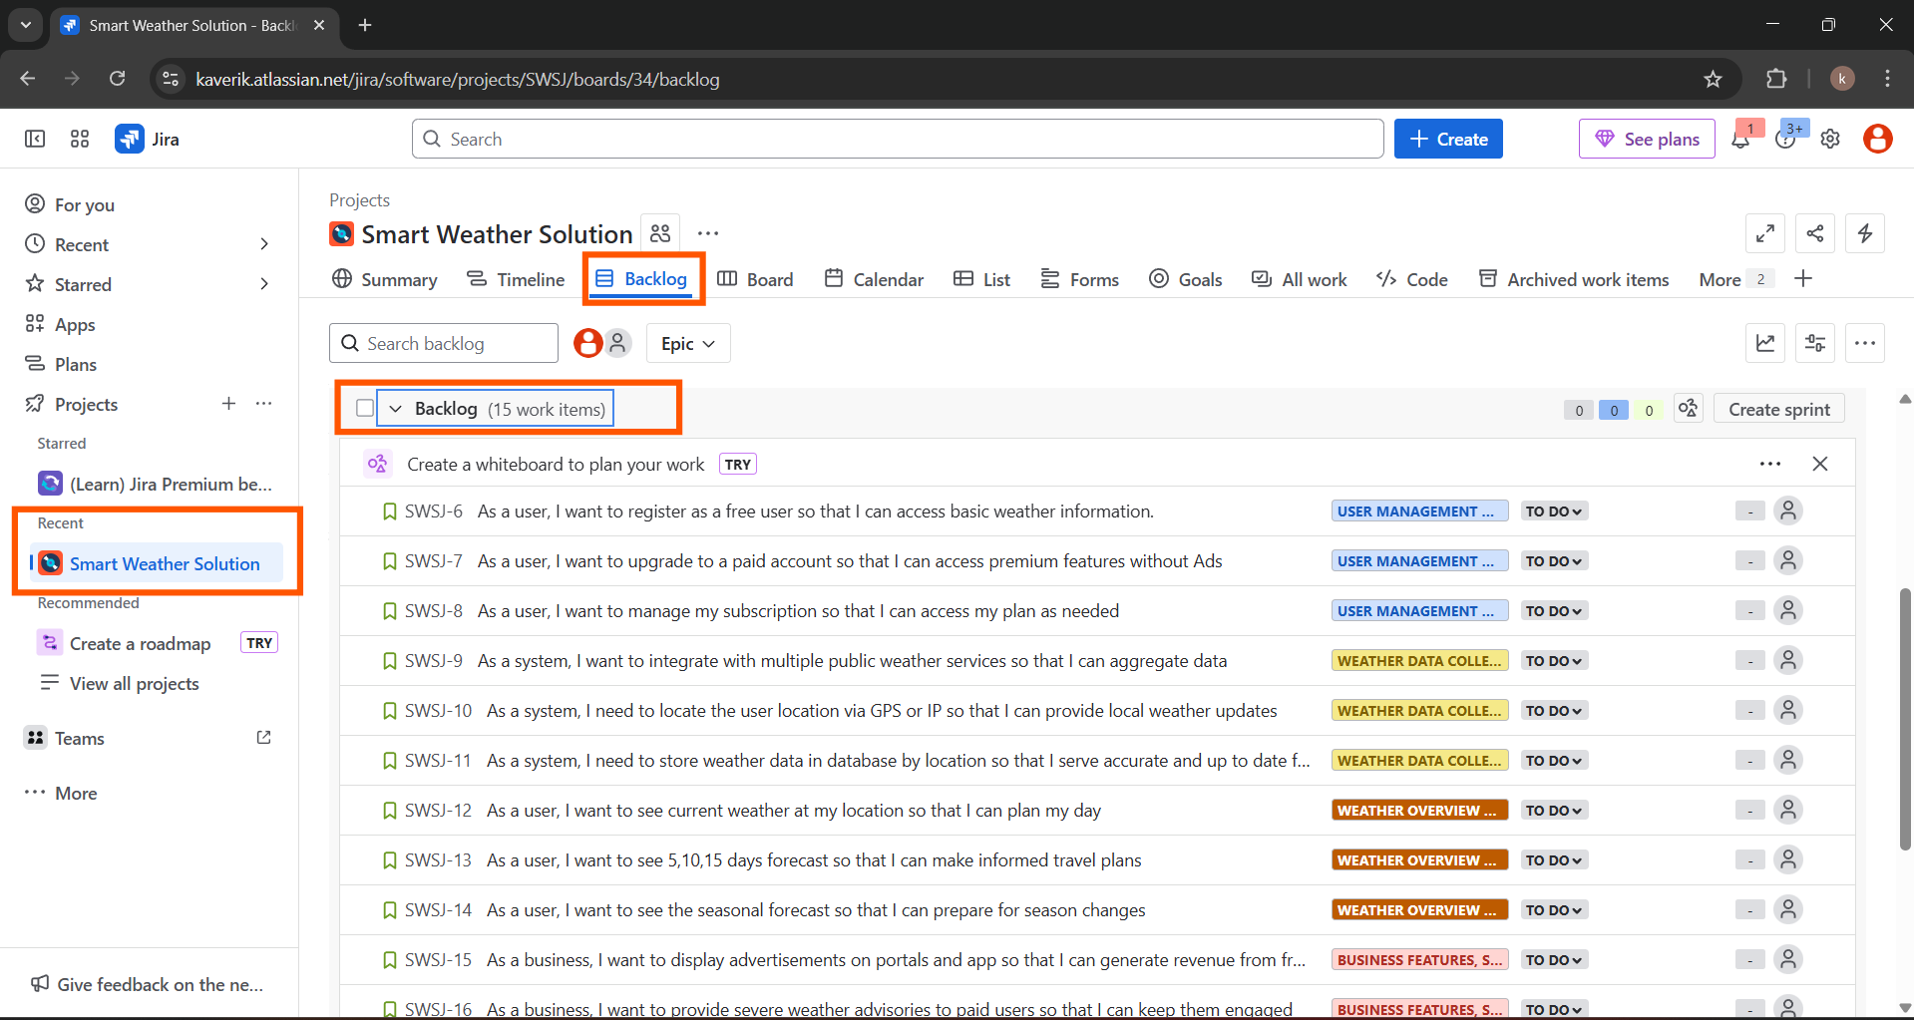

Task 4
Make a tentative release plan, by assigning the stories to three sprints.
Sprint 1
User registration and core set up

The Sprint 1 focused on building the foundational components, including user registration and basic weather forecast functionality. The goal was to enable users to securely sign up and begin interacting with the Smart Weather platform.
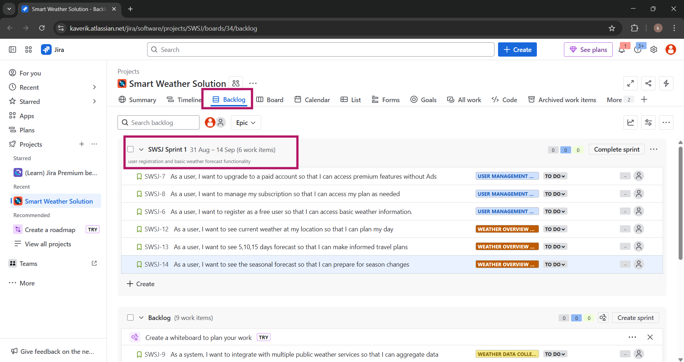
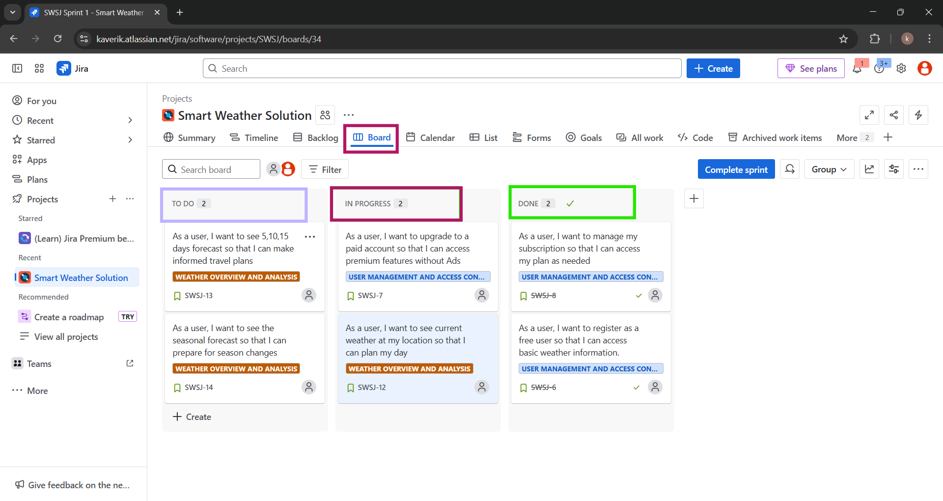
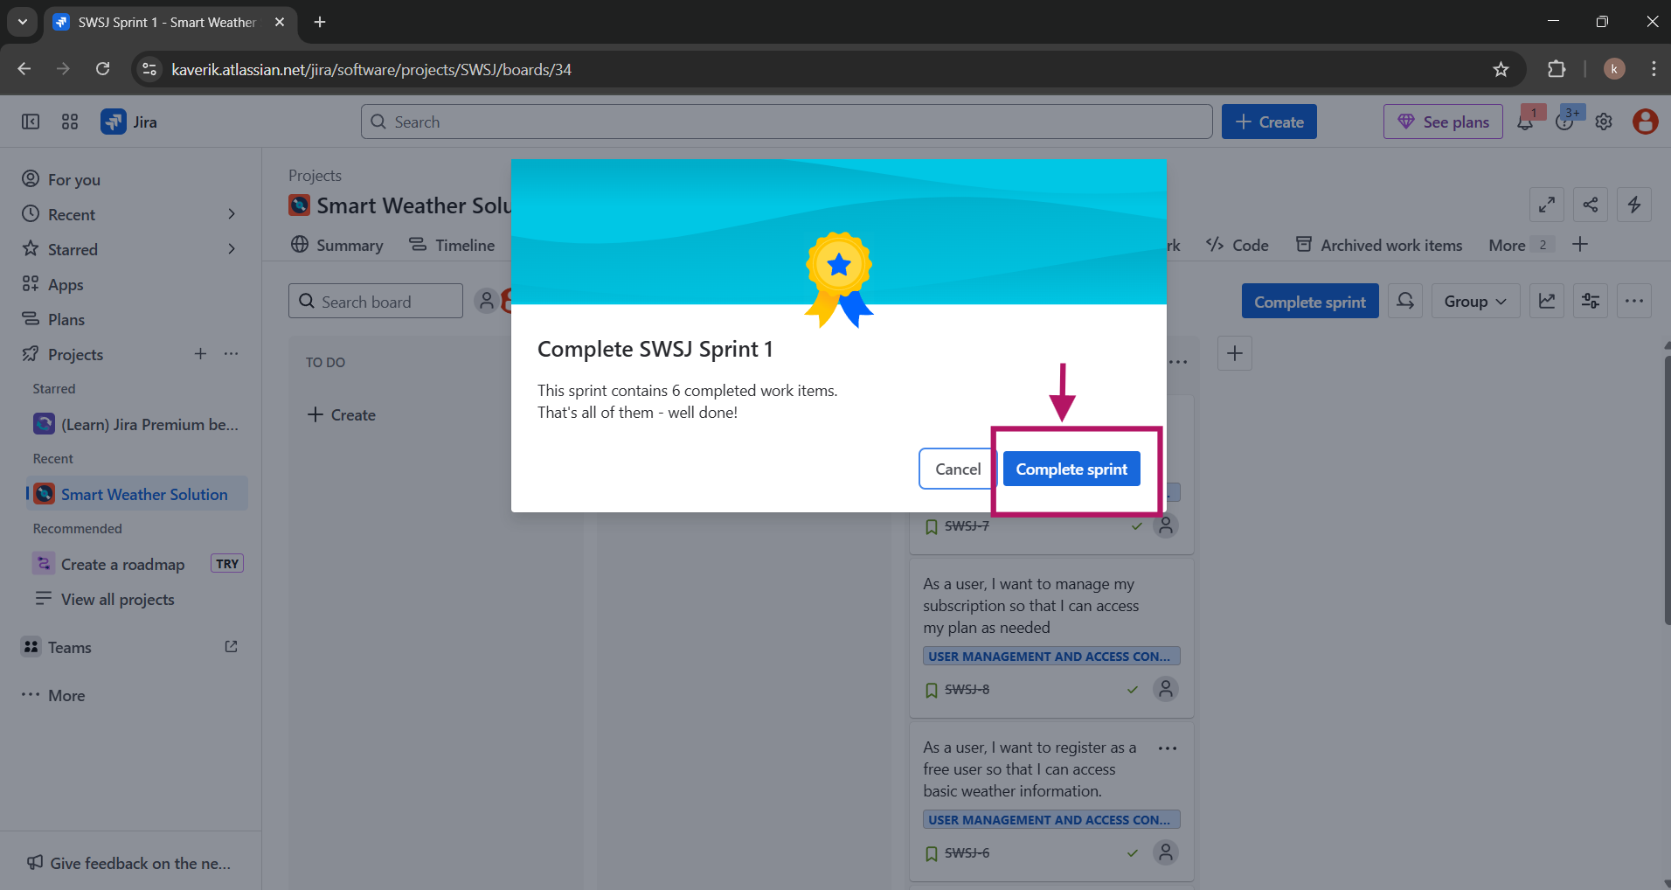

Sprint 2
Data Aggregation & Forecasts

Sprint 2 emphasized back end development for weather data aggregation and integration with external APIs. It also included enhancements to the forecast logic for more accurate predictions.
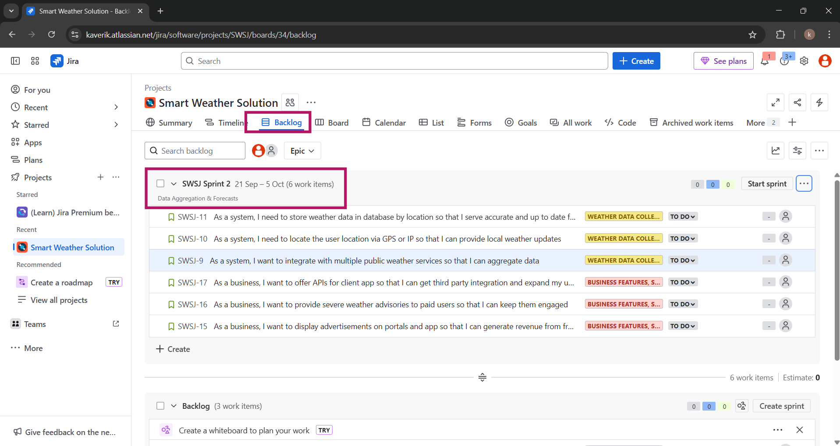
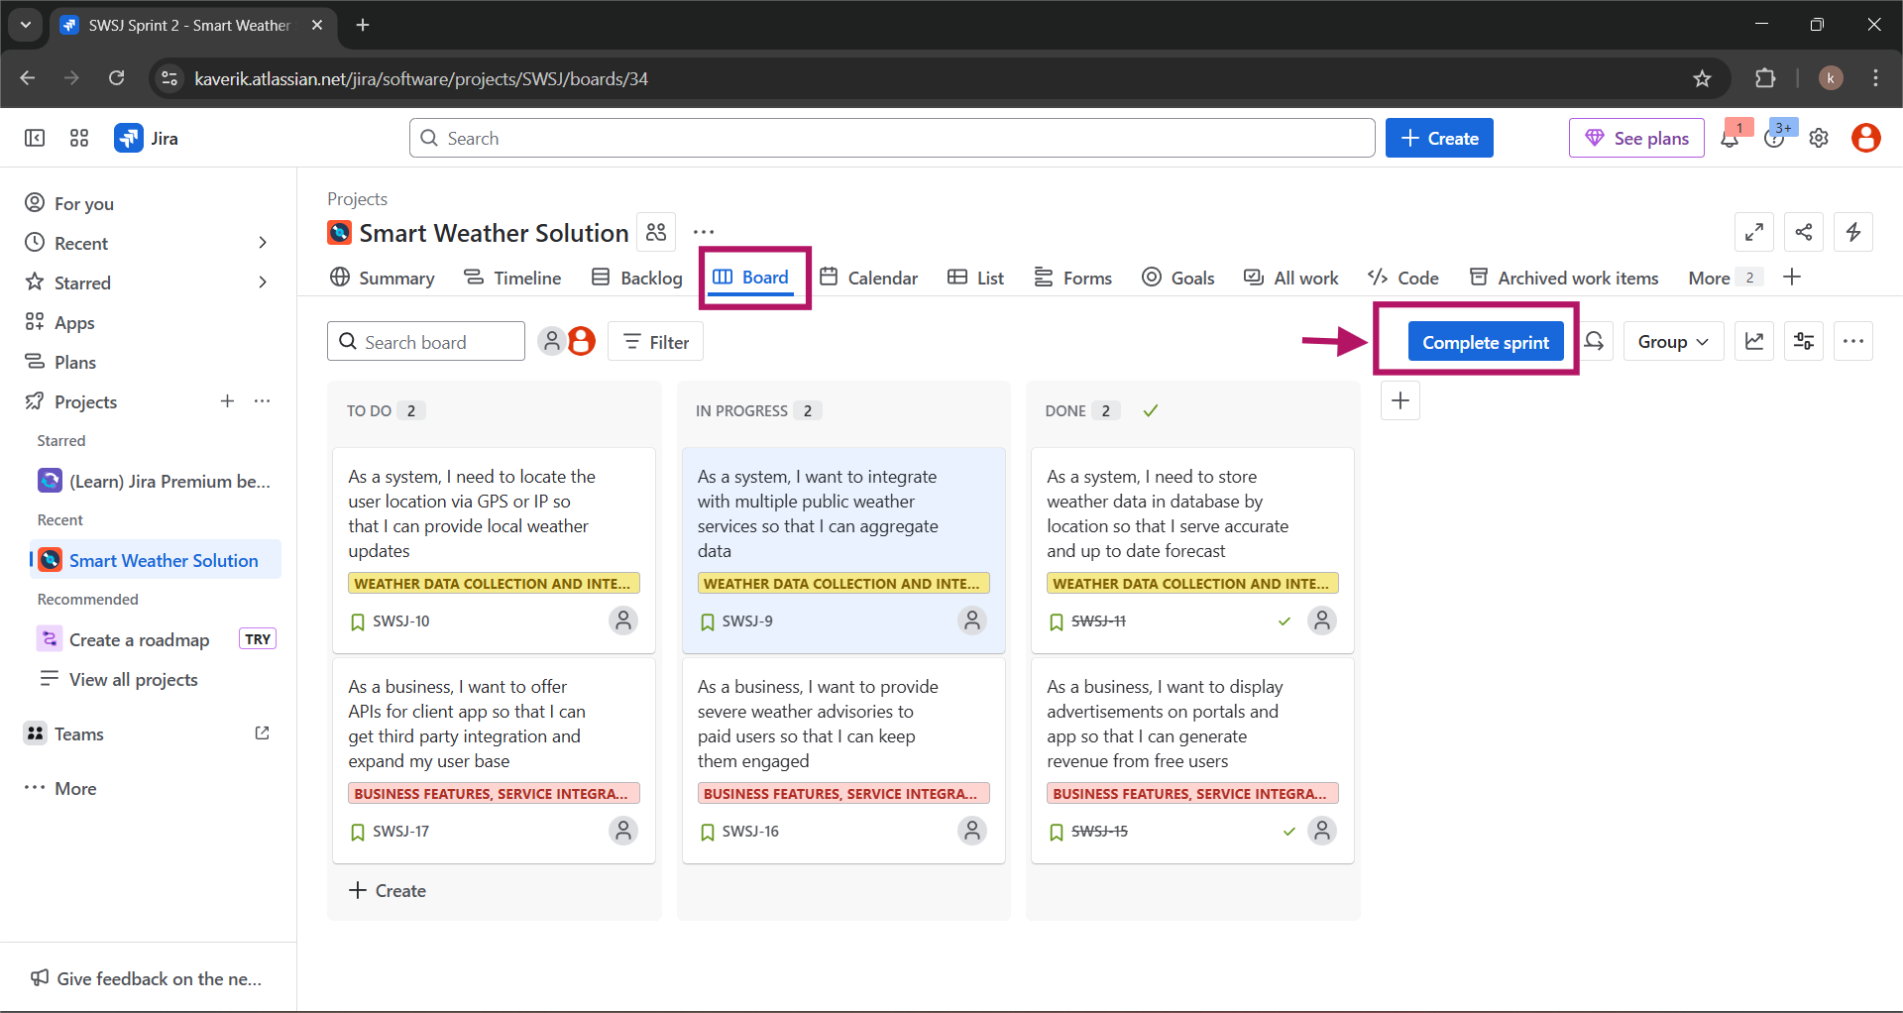
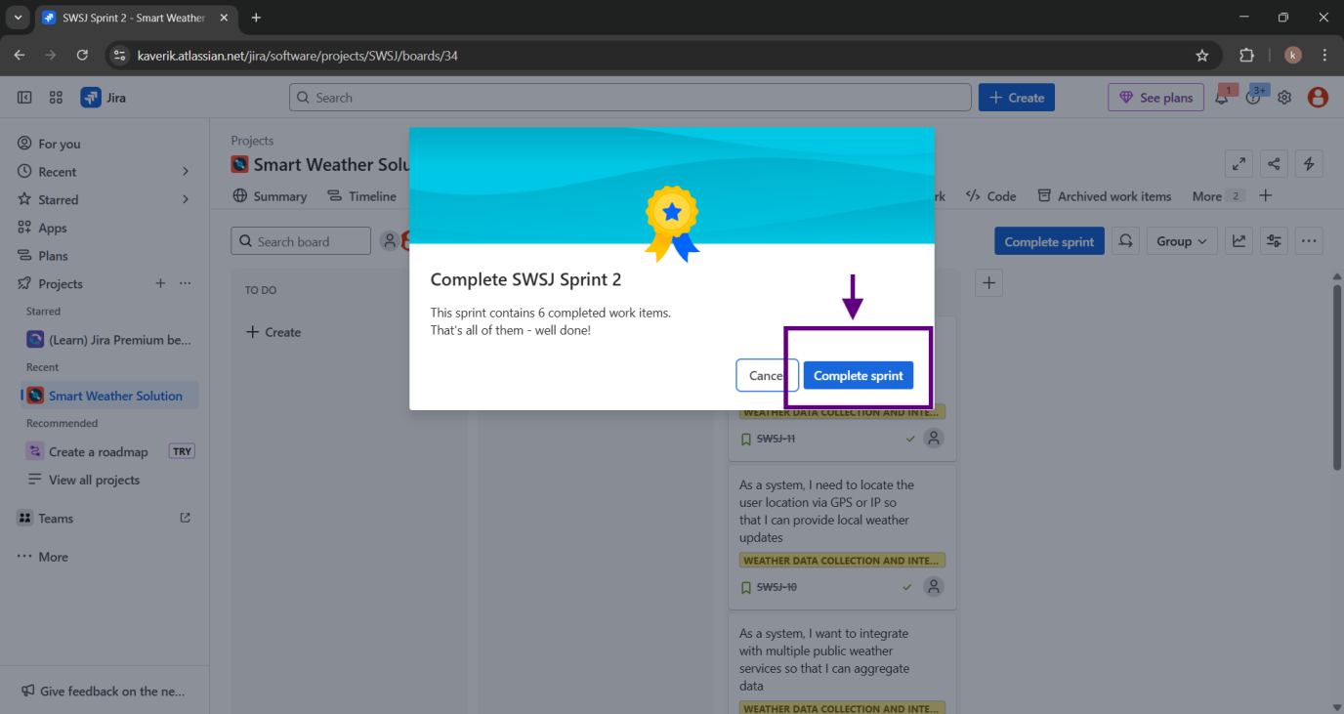

Sprint 3
User experience across mobile platforms and adding monetization features
The Sprint 3 focused on improving the user experience across mobile platforms and adding monetization features. Tasks also included setting up subscription models and enabling targeted in-app ads via APIs.
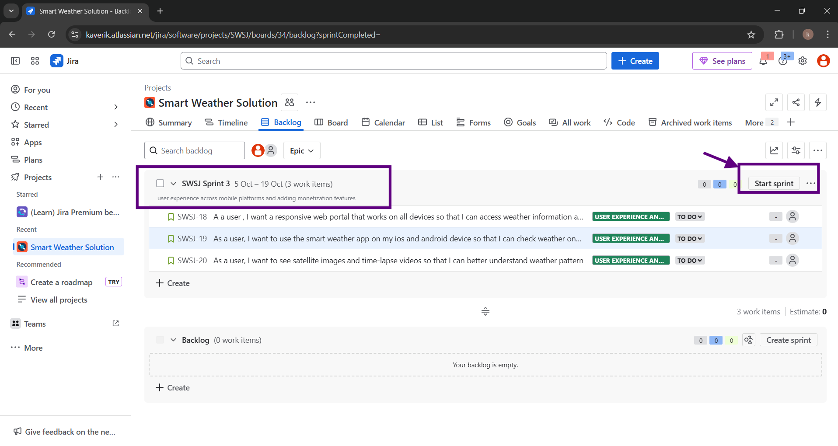
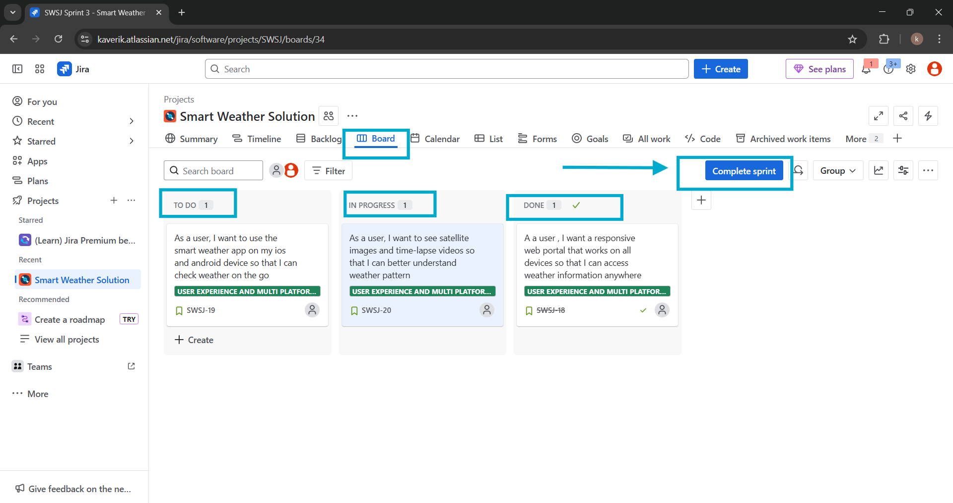
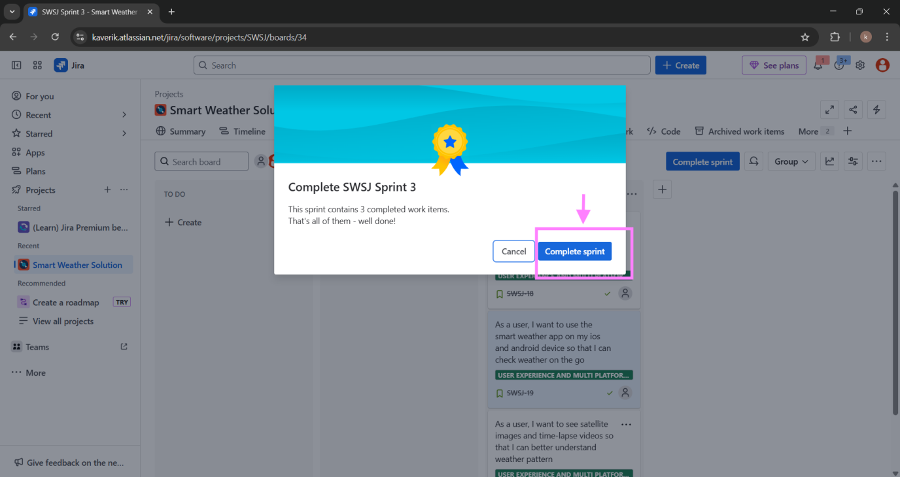

Roadmap
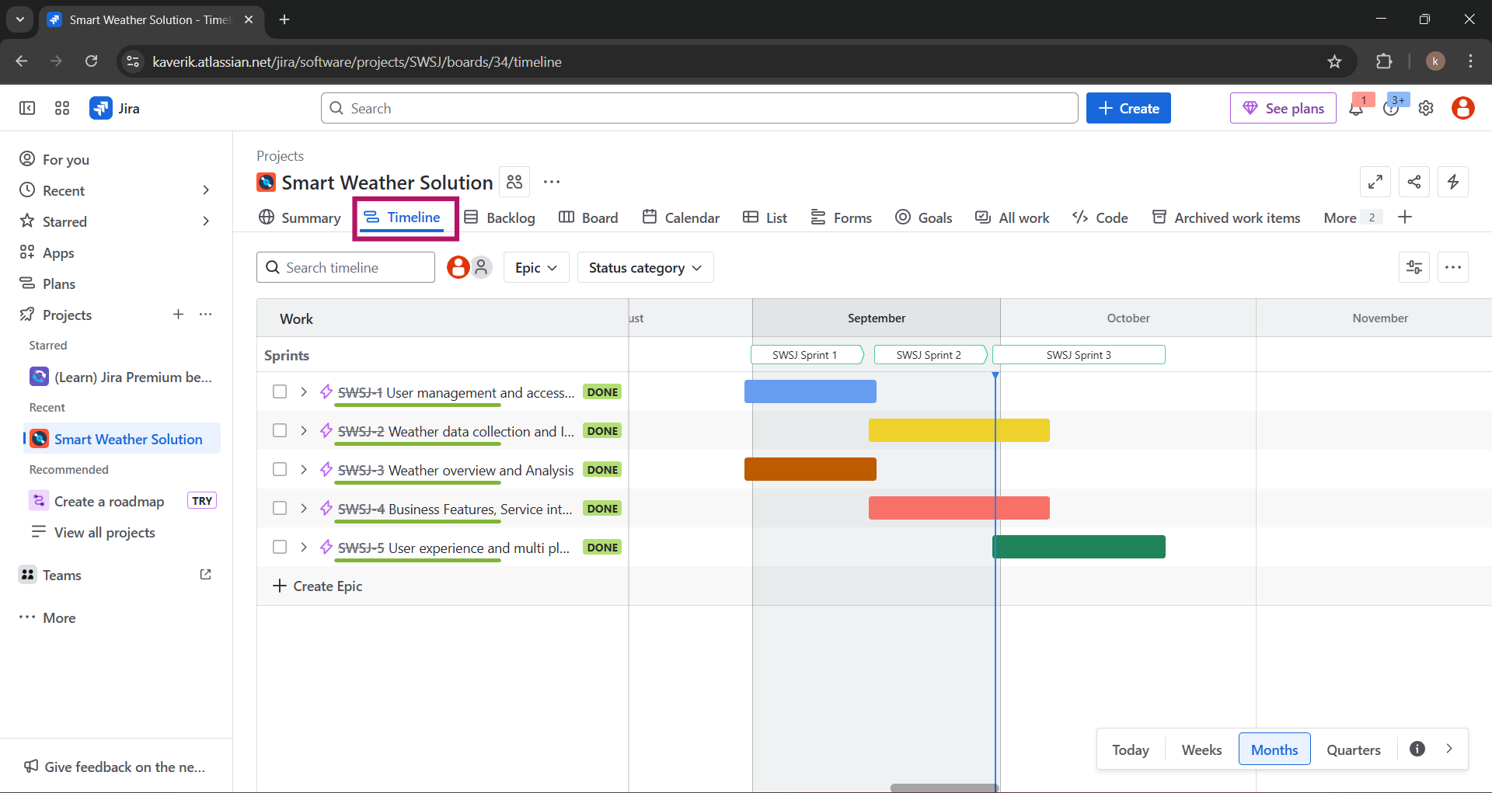

Release Plan

Following the successful completion of Sprint 1, Sprint 2, and Sprint 3, the Release Plan outlines the upcoming delivery of the Smart Weather Solution platform.
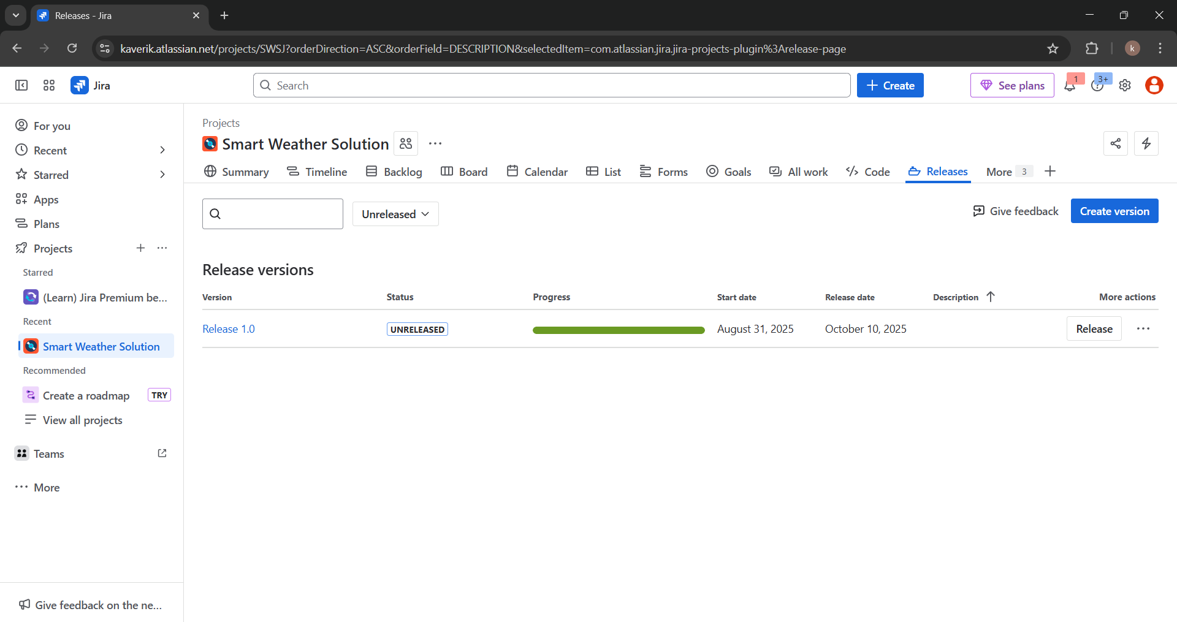
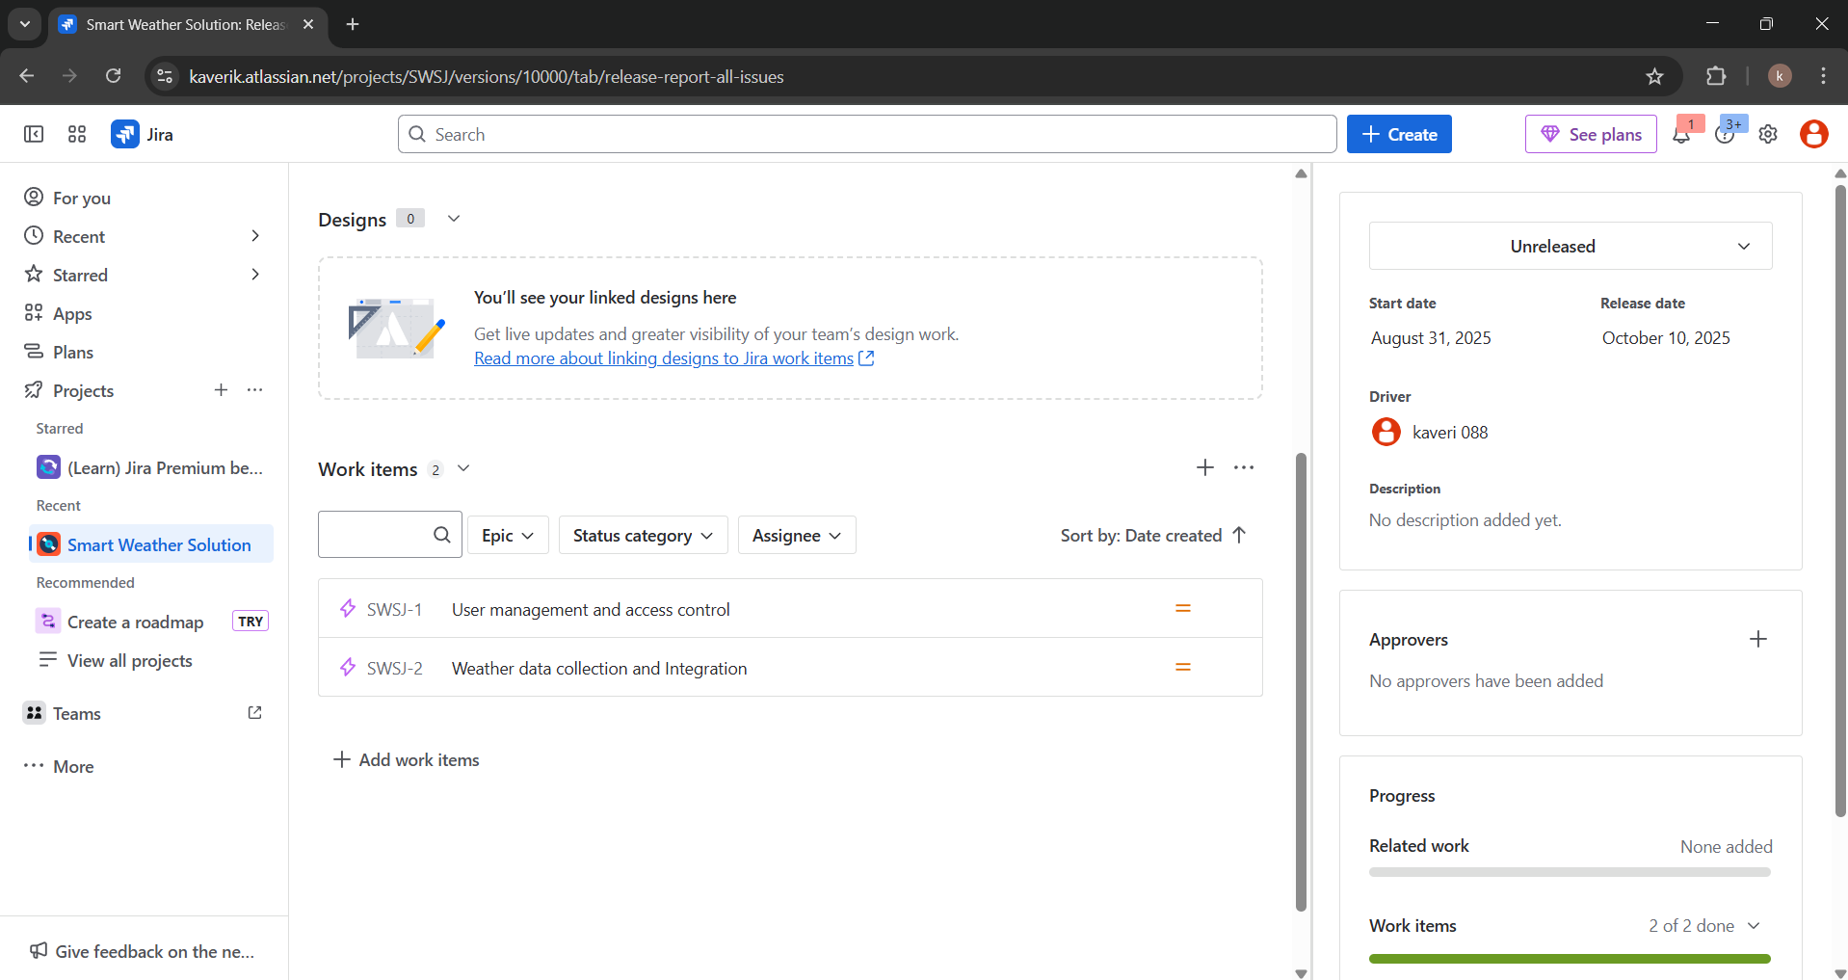

This initial release is focused on delivering a robust, scalable weather Analytics solution with key features such as:
● User registration (free & paid)
● Location detection (GPS/IP-based)
● Real-time weather integration with public APIs
● Database schema for weather data by location
● Display of weather conditions based on the user's location.

The platform empowers businesses in logistics, agriculture, and tourism with accurate weather insights for operational decision-making. The release is currently marked "Unreleased".

Task 5
Start and complete one sprint
Sprint 1

Through this project, I applied Agile Scrum Master concepts to a real-world inspired case of GTM Systems' SmartWeather platform. I identified 5 epics and 15 user stories from business requirements and mapped them to clear deliverables.
Using JIRA, I created a Scrum project, structured the product backlog, and detailed each story.
I planned and executed three sprints, focusing on feature prioritization, incremental delivery, and stakeholder value. Each sprint included backlog grooming, task allocation, and status tracking via the Scrum board.
I ensured sprint progress was visible through Jira workflows — from To Do to Done. The final Release Plan outlines delivery of a reliable weather data platform for business users.

